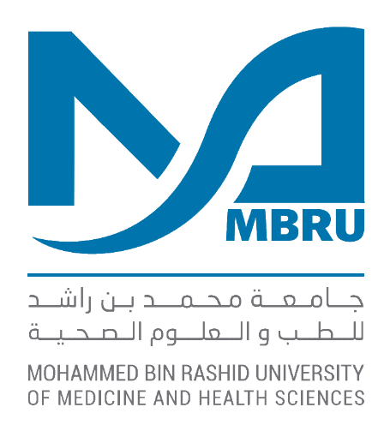

MOHAMMED BIN RASHID UNIVERSITY OF MEDICINE AND HEALTH SCIENCES

MBRU-ALMAHMEED
Collaborative Research Award
Application Form

2018

MBRU-ALMAHMEED COLLABORATIVE RESEARCH AWARD
APPLICATION FORM
2018

- PROPOSAL TITLE AND TOTAL REQUESTED BUDGET

Project Title

Total Budget Requested* (AED)

- ETHICS APPROVAL: If human or human samples/tissues or animals or animal samples/tissues are to be used in the research project, the applicant cannot start the project before ethical approval has been granted from the MBRU Institutional Review Board (IRB) and any other relevant ethics committee, even if funding has been approved.

Details
☐ Not Applicable
Justify
☐ To be Submitted
Indicate planned submission date
☐ Submitted
Indicate submission date
☐ Approved
Provide approval # and authorizing body

- PRINCIPAL INVESTIGATOR

Name |  |  | Degree
Title |  | Department | College
Submission Date | Phone # | E-mail
Signature

- CO-INVESTIGAOTRS/COLLABORATORS

Name | Affiliation | Role in the Project | Signature*

*In place of a signature, a signed letter of support from the co-investigator(s) will suffice.

- COLLEGE ADMINISTRATORS

Administrator | Name | Signature
Department/Program Chair
College Dean

- ABSTRACT (maximum 300 words):

- PROJECT DESCRIPTION (A-E, max. 5 pages in total)

- INTRODUCTION: Describe the background and the current understanding of the literature pertaining to the project.

- OBJECTIVES AND SPECIFIC AIMS: Describe the overall objectives and list the specific aims of the project.

- RESEARCH PLAN: Describe the specific methods to be used, the study design including any potential inadequacies or caveats and ways to address them, as well as the expected outcomes of the work. Please include sample size justification if applicable.

- RELEVANCE TO UAE: Describe the potential relevance of the project to the UAE and the potential opportunities for capacity building as well as long-term positive impact on medical, health-related, social, economic, or environmental issues in the UAE?

- BIBLIOGRAPHY: List the cited references.

- BUDGET SUMMARY*: Indicate the requested budget for each category.

Budget Category | Budget (AED)
- Consumables, Chemicals, and Customized Reagents/Material
- Equipment
- Personnel (for laboratory-based projects, this can be up to a maximum of 50% of the requested budget and for non-laboratory-based projects, it can exceed 50% of the requested budget with justification)
- Conference Travel (maximum of AED 10,000)
- Animal Expenses or Subject Reimbursements
- Other (e.g. publication costs)
Total Budget (AED)

- BUDGET JUSTIFICATION: Please justify the requested budget for each category.

Budget Category | Justification
1.
2.
3.

4.

5.

6.

- OTHER GRANTS: Please provide titles, source of funding, total budget, duration, and your role in the project of all active and pending grants relevant to this project on which your name or that of your co-investigator(s) appear. Please indicate any significant overlap with other funded or pending grants.

- CURRICULUM VITAE: Provide a short (2-page) CV of the PI and the Co-investigators highlighting qualifications relevant to this application, recent publications, relevant grants.

